vMeme: | Beige | Purple | Red | Blue | Orange | Green | Yellow | Turqouise
Seen by  Beige | 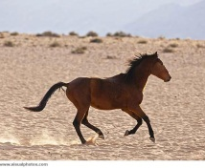 | 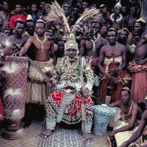 | 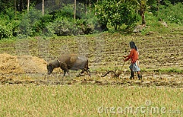 | 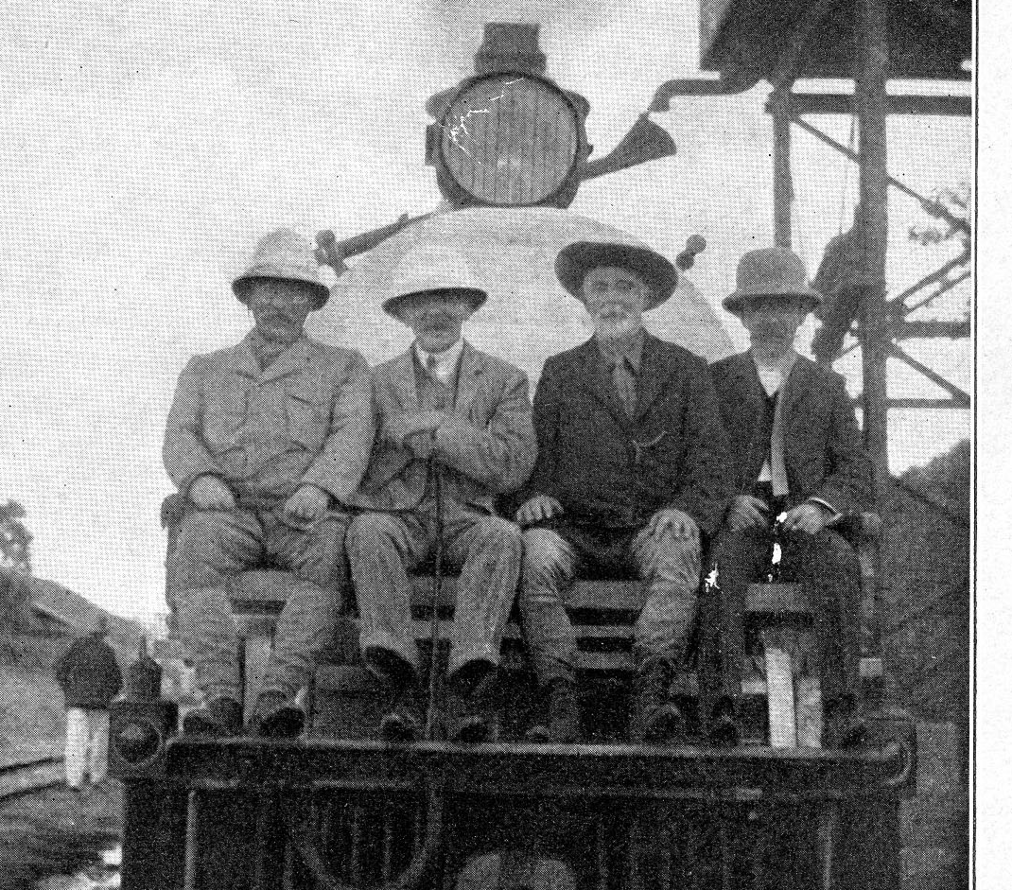 | 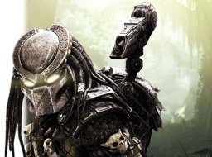 |  | 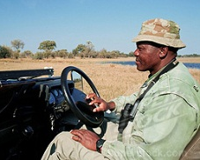 | 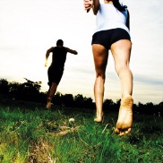
Seen by Purple | 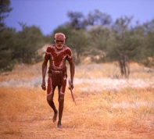 | 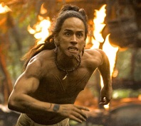 | 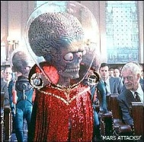 | 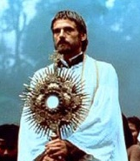 |  | 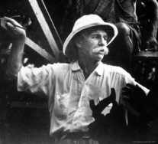 | 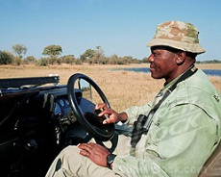 | 
Seen by Red | 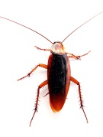 |  | 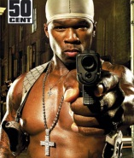 | 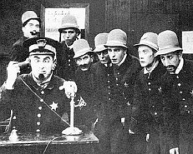 |  | 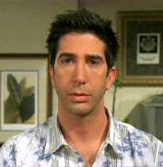 |  | 
Seen by Blue |  |  | 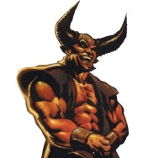 | 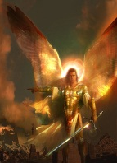 | 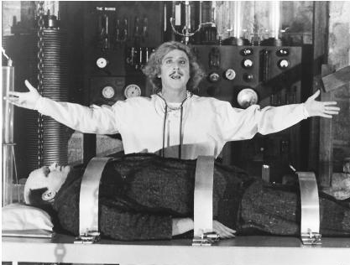 |  | 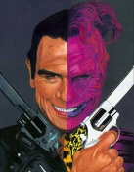 | 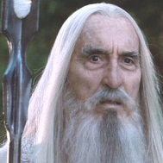
Seen by Orange | 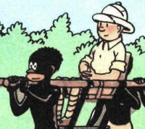 |  |  | 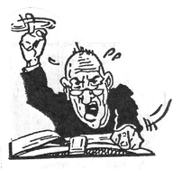 |  | 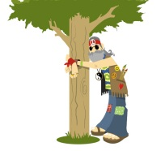 |  | 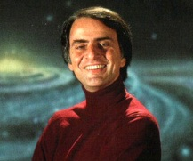
Seen by Green | 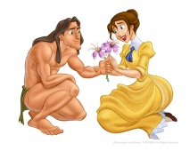 | 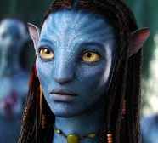 | 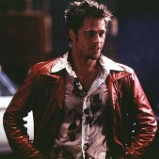 | 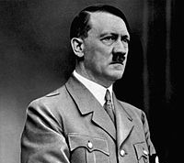 |  | 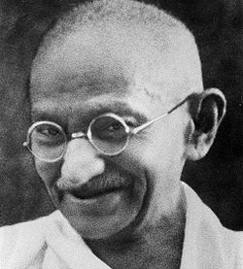 | 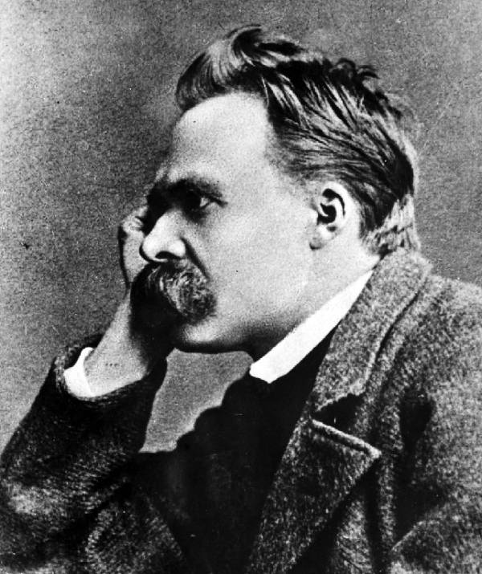 | 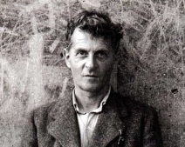
Seen by Yellow | 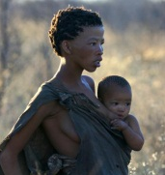 | 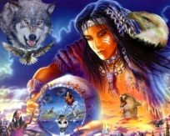 | 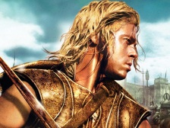 |  | 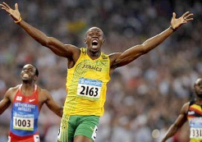 | 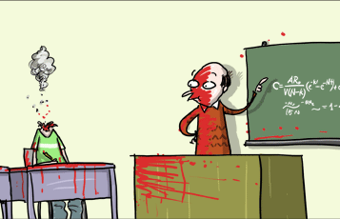 | 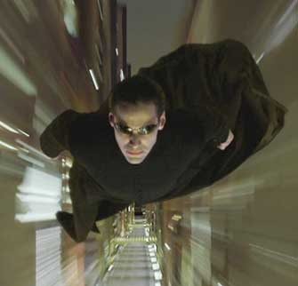
Seen by Turqouise | 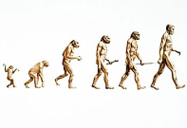 | 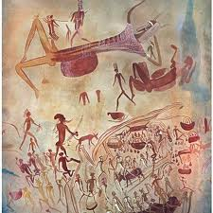 | 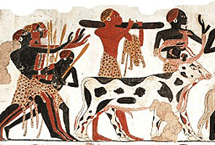 | 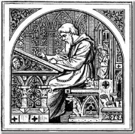 | 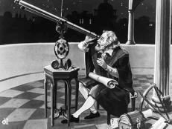 | 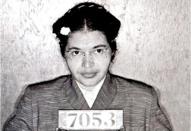 |  | 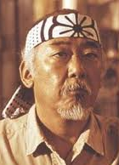
@kristian_stalne
vMeme: | Beige | Purple | Red | Blue | Orange | Green | Yellow | Turqouise
Seen by  Beige | Running horse | Big tribe | Farming guy | White game hunters | Predator | Herbert from Family guy | Park ranger | Two guys barefoot running
Seen by Purple | Solo aborigin | Jaguar paw from Apocalypto | Martian from Mars attacks | Jeremy Irons from the Mission | White oil prospector | Albert Schweitzer | Park ranger | Snoopy and Woodstock
Seen by Red | Cockroach | Cockroach | 50 Cent | Police constables | Moneybag | David Schwimmer from Friends | Young Brad Pitt | Invisible man
Seen by Blue | Orangutang | Witch | Devil | Archangel | Mad scientist, prof Frankenstein | Pee-wee Herman | Two-face from Batman | Sauron from LOTR
Seen by Orange | Black guy from Tintin in Kongo | Boy with monster under bed | Tony Montana from Scarface | Rabid preacher | Tom Cruise from Top gun | Tree hugging hippie | Information processor from Minority report | Carl Sagan
Seen by Green | Disney’s Tarzan | Neytiri from Avatar | Tyler Durden from Fight club | Adolf Hitler | Montgomery Burns | Mahatma Gandhi | Friedrich Nietzsche | Ludwig Wittgenstein
Seen by Yellow | African woman with child | Native American woman with spirits | Brad Pitt as Achilles in Troy | Rabbi and pope | Usain Bolt | Student with exploding head from Wulffmorgenthaler | Flying Neo from Matrix | Student with exploding head from Wulffmorgenthaler
Seen by Turqouise | Ascent of man | Hunter cave paintings | Egyptian farm art | Writing monk | Galileo Galilei | Rosa Parks | Tom Anderson from Matrix | Mr Myagi from Karate kid

